Lecture 1
Innovative Methods of Teaching

Abstract/ Purpose –The purpose of this paper is to evaluate the traditional methods of teaching as well as multimedia teaching and to suggest other useful teaching methods that can be attempted in imparting knowledge to the students. Basically teaching must include two major components sending and receiving information. Ultimately, a teacher tries his best to impart knowledge as the way he understood it. So, any communication methods that serve this purpose without destroying the objective could be considered as innovative methods of teaching. The use of innovative methods in educational institutions has the potential not only to improve education, but also to empower people, strengthen governance and galvanize the effort to achieve the human development goal for the country.

I.Introduction

Education is a light that shows the mankind the right direction to surge. The purpose of education is not just making a student literate but adds rationale thinking, knowledgeablity and self sufficiency. When there is a willingness to change, there is hope for progress in any field. Creativity can be developed and innovation benefits both students and teachers.

II.Importance of Education:
Islam attaches such great importance to knowledge and education. When the Qur'an began to be revealed, the first word of its first verse was 'Iqra' that is, read. Education is thus the starting point of every human activity. A scholar (alim) is accorded great respect in the hadith. According to a hadith the ink of the pen of a scholar is more precious than the blood of a martyr. The reason being that martyr is engaged in defense work while an alim (scholar) builds individuals and nations along positive lines. In this way he bestows a real life to the world.
“Education is the manifestation of perfection already in man” –
(Swami Vivekananda)
Education is a light that shows the mankind the right direction to surge. If education fails to inculcate self-discipline and commitment to achieve in the minds of student, it is not their fault. We have to convert education into a sport and learning process has to generate interest in the students and motivate them to stay back in the institution than to run away from it. Education should become a fun and thrill to them rather than burden and boredom. It is an integral part of their growth and helps them become good citizens.
Education is an engine for the growth and progress of any society. It not only imparts knowledge, skills and inculcates values, but is also responsible for building human capital which breeds, drives and sets technological innovation and economic growth. In today’s era, information and knowledge stand out as very important and critical input for growth and survival. Rather than looking at education simply as a means of achieving social upliftment, the society must view education also as an engine of advancement in an information era propelled by its wheels of knowledge and research leading to development.

III.Methodology
The traditional or innovative methods of teaching are critically examined, evaluated and some modifications in the delivery of knowledge is suggested. As such, the strengths and weaknesses of each teaching methodology are identified and probable modifications that can be included in traditional methods are suggested.

IV. Traditional Teaching Method – An evaluation
In the pre-technology education context, the teacher is the sender or the source, the educational material is the information or message, and the student is the receiver of the information. In terms of the delivery medium, the educator can deliver the message via the “chalk-and- talk” method and overhead projector (OHP) transparencies. This directed instruction model has its foundations embedded in the behavioral learning perspective (Skinner, 1938) and it is a popular technique, which has been used for decades as an educational strategy in all institutions of learning.
Basically, the teacher controls the instructional process, the content is delivered to the entire class and the teacher tends to emphasize factual knowledge. In other words, the teacher delivers the lecture content and the students listen to the lecture. Thus, the learning mode tends to be passive and the learners play little part in their learning process (Orlich et al.,1998). It has been found in most universities by many teachers and students that the conventional lecture approach in classroom is of limited effectiveness in both teaching and learning. In such a lecture students assume a purely passive role and their concentration fades off after 15-20 minutes.
Some limitations which may prevail in traditional teaching method are
 Teaching in classroom using chalk and talk is “one way flow” of information.
MESSAGE
SENDER RECIEVER

(TEACHER) (STUDENT)
MEDIUM

- Teachers often continuously talk for an hour without knowing students response and feedback.
- The material presented is only based on lecturer notes and textbooks.
- Teaching and learning are concentrated on “plug and play” method rather than practical aspects.
- The handwriting of the lecturer decides the fate of the subject.
- There is insufficient interaction with students in classroom.
- More emphasis has been given on theory without any practical and real life time situations.
- Learning from memorization but not understanding.
- Marks rather than result oriented.

V.INNOVATIVE TOOLS

(A)MULTIMEDIA LEARNING PROCESS
I hear and I forget.
I see and I believe.
I do and I understand. - Confucius
Multimedia, is the combination of various digital media types such as text, images, audio and video, into an integrated multi-sensory interactive application or presentation to convey information to an audience. Traditional educational approaches have resulted in a mismatch between what is taught to the students and what the industry needs. As such, many institutions are moving towards problembased learning as a solution to producing graduates who are creative; think critically and analytically, to solve problems. In this paper, we focus on using multimedia technology as an innovative teaching and learning strategy in a problem-based learning environment by giving the students a multimedia project to train them in this skill set.
Currently, many institutions are moving towards problem-based learning as a solution to producing graduates who are creative and can think critically, analytically, and solve problems. Since knowledge is no longer an end but a means to creating better problem solvers and encourage lifelong learning. Problem-based learning is becoming increasingly popular in educational institutions as a tool to address the inadequacies of traditional teaching. Since these traditional approaches do not encourage students to question what they have learnt or to associate with previously acquired knowledge (Teo & Wong, 2000), problem-based learning is seen as an innovative measure to encourage students to learn how to learn via real-life problems (Boud & Feletti, 1999).
The teacher uses multimedia to modify the contents of the material. It will help the teacher to represent in a more meaningful way, using different media elements. These media elements can be converted into digital form, modified and customized for the final presentation. By incorporating digital media elements into the project, the students are able to learn better since they use multiple sensory modalities, which would make them more motivated to pay more attention to the information presented and retain the information better.

Chart 1 - MULTMEDIA ELEMENTS
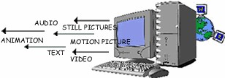

Creating multimedia projects is both challenging and exciting. Fortunately, there are many multimedia technologies that are available for developers to create these innovative and interactive multimedia applications (Vaughan, 1998). These techologies include Adobe Photoshop and Premier to create edit graphics and video files respectively, SoundForge and 3D Studio Max to create and/or edit sound and animation files, respectively. They can also use an authoring tool such as Macromedia Director or Authorware to integrate and synchronise all these media elements into one final application, add interactive features, and package the application into a distributable format for the end-user.
Another advantage of creating multimedia projects in the classroom setting is that when students create multimedia projects, they tend to do this in a group environment. By working in a group, the students would have to learn to work cooperatively and collaboratively, using their group skills and a variety of activities to accomplish the project’s overall objectives.
TRADITIONAL AND MULTIMEDIA LEARNING THE DIFFERNCE

Chart 2 - TRADITIONAL METHOD – A ONE WAY FLOW

STUDENTS

TEACHER

Chart 3 - MULTIMEDIA LEARNING – AN INTERACTIVE LEARNING PROCESS
STUDENT 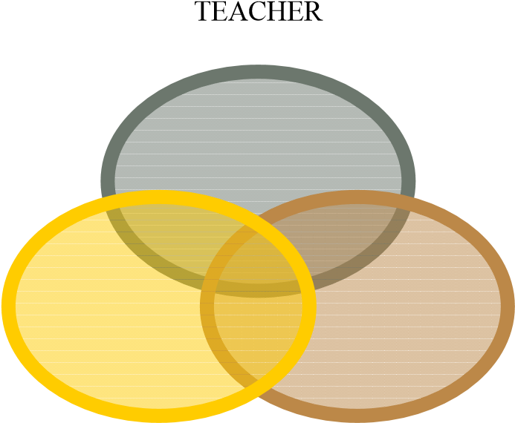 MULTIMEDIA

VARIOUS MULTIMEDIA TOOLS
Tools | METHODS | EXAMPLES | METAPHORS
Mspowerpoint, Astound  Graphics and Flash Slide  Show Software | Easy to prepare and it can be prepared with many of the popular multimedia elements like graphs, sound and video. | 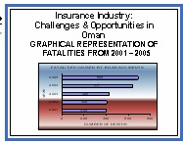 | SLIDE BASED
Macromedia, Flash Authorware, BPP I  Learn and I Pass | Presentation is created using icons to represent different media elements and placed in a flowline. |  | ICON BASED
Windows Movie Maker, Winampp, Macromedia  Director | Presentation is  created using moviemaking concepts of casts, sounds,  pictures and scores |  | MOVIE  BASED
Adobe Acrobat Reader | Easy to prepare and with word documents if u have Acrobat Reader 5 with many popular multimedia elements like graphs sound and charts | 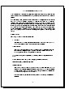 | BOOK BASED

(B)OTHER INNOVATIE TOOLS SUGGESTED
The researchers suggest some of the methods can very well be applied by the modern teachers. As the researchers feel that basically the core objective of teaching should never be deviated by the use of an innovative method. The following methods which are suggested are an extension to the traditional methods of teaching.

(1) MIND MAP
Mind maps were developed in the late 60s by Tony Buzan as a way of helping students make notes that used only key words and images, but mind map can be used by teachers to explain concepts in an innovative way. They are much quicker to make and much easier to remember and review because of their visual quality. The nonlinear nature of mind maps makes it easy to link and cross-reference different elements of the map.
Mind Maps are also very quick to review, as it is easy to refresh information in your mind just by glancing once. Mind Maps can also be effective mnemonics and remembering their shape and structure can provide the cues necessary to remember the information within it. They engage much more of the brain in the process of assimilating and connecting facts than conventional notes.
The key notion behind mind mapping is that we learn and remember more effectively by using the full range of visual and sensory tools at our disposal. Pictures, music, color, even touch and smell play a part in our learning armory will help to recollect information for long time. The key is to build up mind maps that make the most of these things building on our own creativity, thinking and cross linking between ideas that exist in our own minds.
As the recent research point that any particular information explained with the help of graph charts make a high impact in the minds of the people and keeping this as the core aspect the teachers may try to picturize the concepts and show the same to the students

Chart 4 - AN EXAMPLE OF MIND MAP FOR SCALAR QUANTITIES
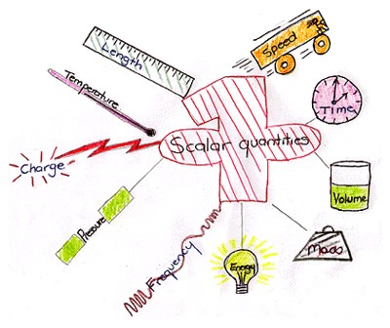

This would bring very high impact on the minds of the students about a concept
- Creates clear understanding  PowerPoint can be used widely.
- Innovative thinking improves

